Space Meeting Ideas

www.shac.org/space-theme

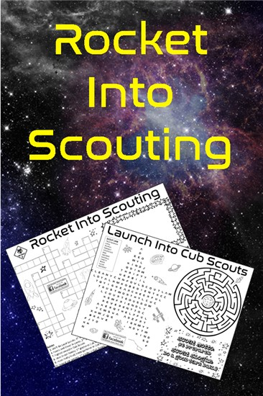
Cub Scouts can learn which constellations and stars light up our sky. Visit a planetarium or star gaze in a remote area. Don’t forget that the stars in the sky are not the only “stars” that shine. This is a great time for our Cub Scouts to shine by giving service, singing, performing in a skit, or any activity that exemplifies the purposes of Cub Scouting.
It takes courage to explore a new frontier, to cast aside the comfort of the life we know to go forth and explore our universe. Our Cub Scouts show similar courage in exploring the options and challenges of their advancement in Scouting, which we know will help them grow up strong and courageous as they lead our complicated world and learn more about our universe. Top it off with a space derby.
Tigers can work on the Sky Is the Limit adventure, Wolves who participate in the space derby can work on the Air of the Wolf adventure, Webelos Scouts can work on the Adventures in Science adventure.
Space makes a great theme for pack meetings, banquets or day camp.

Content
(Sources: Baloo’s Bugle: Space: The New Frontier (Jun 2000), The New Frontier (Jul 2014), Blast Off (Sep 2002), Cub Scout Stars (Dec 2006), BSA: The New Frontier (Jul 2013). Related, but not included: Baloo Skies (weather theme: Mar 2007)

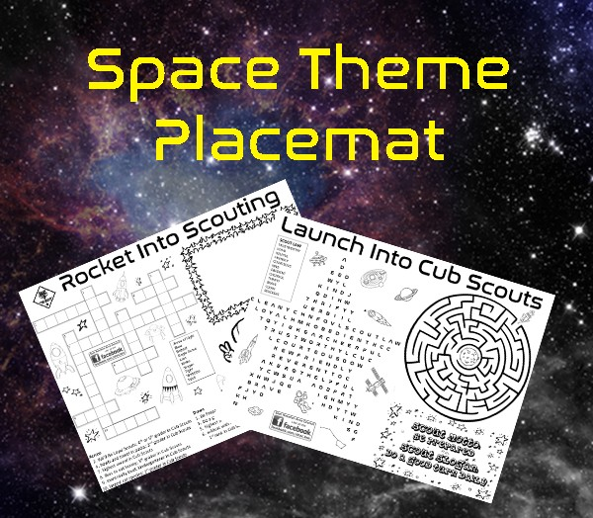
Placemats / Activity Sheet

Free, customizable placemats are available for packs to use at banquets or den meetings to help promote day camp. Download the placemats at shac.org/space-theme

PACK MEETING PLANNING SHEET

Pack Meeting Date: |  | Theme: | Space

Time | Activity | Materials | Responsible
6:30 pm | Before the meeting | - set up chairs  - sound system  - flags  - advancement table
6:45 pm | Gathering | - activity sheet  - pencils  - pack meeting handouts | - (greeters)
7:00 pm | Welcome | - safari hat | - Cubmaster
7:01 pm | Opening: Space Opening Ceremony  S is for Scouting. Like space exploration, we look forward to the future with great expectation.  P is for Power Rockets. We need them to go and so does Scouting need power, but that you know.  A is for Altitude - that the astronauts gain and like them, the Cub Scouts' great heights will attain.  C is for Character. It takes character to be an astronaut or Cub Scout Just like me!  E is for Energy, to conserve it, astronauts rest. And energy is what we put forth, as Den Leader: Cub Scouts doing their best. Please rise and join us in the Pledge of Allegiance. | - 5 Cub Scouts  - Den leader or CM  - S-P-A-C-E posters with script on back  - cheer box  - printed cheers | - ___ Den  - den leader
7:03 | Flag Ceremony | - 2+ Cub Scouts  - flags  - pocket guide | - ___ Den  - den leader  - assistant Cubmaster (leads cheer)
7:06 | Invocation  The prayer Astronaut Frank Borman while on a moon orbiting mission in December 1968.  “Give us, O God, the vision which can see the love in the world, in spite of our failure. Give us the faith to trust Thy goodness in spite of our ignorance and weakness. Give us the knowledge that we may continue to pray with understanding hearts, and show us what each one of us can do to set forward the spirit of universal peace." AMEN | - printed script
7:08 | Program |  | - ___ Den  - den leader
7:15 | Song  List on pack meeting handout | - pack meeting handout | - ___ Den  - den leader
 | Leader Recognition (if applicable) | - printed script  - recognition items | - committee chair  - Cubmaster (assists)
7:17 | Skit (optional) |  | - ___ Den  - den leader  - assistant Cubmaster (leads cheer)
 | Audience Participation (optional) | - printed script | - Cubmaster  - assistant Cubmaster (leads cheer)
7:20 | Advancement Ceremony: Rocket Advancement Ceremony  Personnel: Cubmaster, assistant Cubmaster, Cub Scouts receiving awards, their parents.  Equipment: Large cardboard rocket made with four stages and a capsule. Cut small windows in each section. Cover with colored cellophane paper. Attach a flash light or candle behind each stage to show each rank. Have the assistant Cubmaster light each section as the Cub Scouts are called forward.  Cubmaster: As the rocket reaches toward the stars in stages, so it is in Cub Scouting.  The first stage is Lion. This is the launching pad. Would the following Cub Scouts and their parents please come forward? (Read names, present awards, conduct cheer and let them return to their seats.)  The second stage in your journey is Tiger, the booster rockets that lifted the rocket off the pad. Would the following Tigers and their parents please come forward? (Read names, present awards, conduct cheer and let them return to their seats.)  The third stage in your journey is Wolf, which carries you through the atmosphere. Would the following Tigers and their parents please come forward? (Read names, present awards, conduct cheer and let them return to their seats.) The fourth stage is Bear. Now you have broken through the atmosphere and are hurtling through space. Would the following Cub Scouts and their parents please come forward? (Read names, present awards, conduct cheer and let them return to their seats.)  The fifth stage is 4th grade Webelos Scout. You are just about ready to enter orbit. Would the following Cub Scouts and their parents please come forward? (Read names, present awards, conduct cheer and let them return to their seats.)  The sixth and final stage in your journey through Cub Scouting is the hardest to achieve and has taken a lot of hard work, but you made it. You have reached orbit and are looking forward to Scouts BSA. Would the following 5th grade Webelos Scouts and their parents please come forward? (Read names, present awards, conduct cheer and let them return to their seats.) | - awards  - printed script  - cheer box  - printed cheers | - advancement chair  - Cubmaster  - assistant Cubmaster (assists; leads cheer)
 | Game (optional, if time permits) |  | - Cubmaster  - assistant Cubmaster (leads cheer)
7:50 | Song  List on pack meeting handout | - pack meeting handout | - ___ Den  - den leader
7:53 | Announcements | - printed script  - pack meeting handout | - Cubmaster
7:55 | Cubmaster Minute: North Star Cubmaster Minute  When you go out to look at the stars at night, in the northern sky is the North Star called Polaris. For centuries we have known that the North Star is fixed in the heavens, and it has been used for navigation by sailors ever since the first adventurers sailed away from the sight of land. The North Star is still used that way by mariners and space explorers. There are other guiding stars in our everyday lives, too. One of them is our conscience. If we listen to our conscience, we can be sure to steer our lives in the right direction. In Scouting we have our own North Star, the Scout Oath and Law. They are our guiding stars, because they give us excellent guidance in how to behave and what we owe to God, country, our fellow human beings, and to ourselves. When you're lost at night, look for the North Star. The rest of the time, steer your life with those other guiding stars, the Scout Oath and Law. | - printed script | - Cubmaster
7:56 | Closing: Space Shuttle Closing Ceremony  "C" stands for catch. Catch the spirit of Scouting and you're starting the countdown.  "U" stands for unite. When we unite, we see how much we can do and how important teamwork really is.  "B" stands for balance. In Scouting, the hard work that we do can be fun. As a Scout, work and fun are balanced. "S" stands for straight. The Scout Oath and Law remind us that if our arrow is true, we may cross the bridge and become Scouts in troops.  Together these letters form the vehicle that will transport us to the outer limits of Scouting in hopes of one day being able to say those well-earned words, "Another Eagle Has Landed." | - 6 Cub Scouts  - C-U-B-S posters with script on back | - ___ Den  - den leader
7:59 | Closing Flag Ceremony | - flags | - ___ Den  - dean leader
 | After the Meeting |  | - (clean up)

Podium Script: Invocation

Would the audience please rise (pause).

The prayer was broadcast to earth by US Astronaut Frank Borman while on a moon orbiting mission in December 1968.

“Give us, O God, the vision which can see the love in the world, in spite of our failure.

Give us the faith to trust Thy goodness in spite of our ignorance and weakness.

Give us the knowledge that we may continue to pray with understanding hearts, and show us what each one of us can do to set forward the spirit of universal peace." AMEN

Opening Ceremony: Print for back of posters

Space Opening Ceremony
Materials: 5 pieces of cardboard or poster board (or a large cardboard sheet) and cut out a spaceship that is made up of the 5 pieces. Label the pieces with the letters S, P, A, C, and E. (A drawing of the space shuttle is provided below or you can use a very simplistic spaceship drawing.) Have the Cub Scouts form a line across the front of the room and give each Cub Scout a piece of the spacecraft to hold up as they say their lines.

Cub Scout #1: S is for Scouting. Like space exploration we look forward to the future with great expectation.

Cub Scout #2: P is for Power. Rockets need it to go and so does Scouting need power, but that you know.

Cub Scout #3: A is for Altitude that the astronauts gain and like them, the Cub Scouts great heights will attain.

Cub Scout #4: C is for Character. It takes character to be an astronaut or a Cub Scout just like me!

Cub Scout #5: E is for Energy. To conserve energy, astronauts rest. And energy is what we put forth as Cub Scouts doing their best. Please rise and join us in the Pledge of Allegiance.

Podium Script: Advancement Ceremony

Rocket Advancement Ceremony
Personnel: Cubmaster, assistant Cubmaster, Cub Scouts receiving awards, their parents.
Equipment: Large cardboard rocket made with four stages and a capsule. Cut small windows in each section. Cover with colored cellophane paper. Attach a flash light or candle behind each stage to show each rank. Have the assistant Cubmaster light each section as the Cub Scouts are called forward.

Cubmaster: As the rocket reaches toward the stars in stages, so it is in Cub Scouting.

The first stage is Lion. This is the launching pad. Would the following Cub Scouts and their parents please come forward? (Read names, present awards, conduct cheer and let them return to their seats.)

The second stage in your journey is Tiger, the booster rockets that lifted the rocket off the pad. Would the following Tigers and their parents please come forward? (Read names, present awards, conduct cheer and let them return to their seats.)

The third stage in your journey is Wolf, which carries
you through the atmosphere. Would the following Tigers and their parents please come forward? (Read names, present awards, conduct cheer and let them return to their seats.)

The fourth stage is Bear. Now you have broken through the atmosphere and are hurtling through space. Would the following Cub Scouts and their parents please come forward? (Read names, present awards, conduct cheer and let them return to their seats.)

The fifth stage is 4th grade Webelos Scout. You are just about ready to enter orbit. Would the following Cub Scouts and their parents please come forward? (Read names, present awards, conduct cheer and let them return to their seats.)

The sixth and final stage in your journey through Cub Scouting is the hardest to achieve and has taken a lot of hard work, but you made it. You have reached orbit and are looking forward to Scouts BSA. Would the following 5th grade Webelos Scouts and their parents please come forward? (Read names, present awards, conduct cheer and let them return to their seats.)

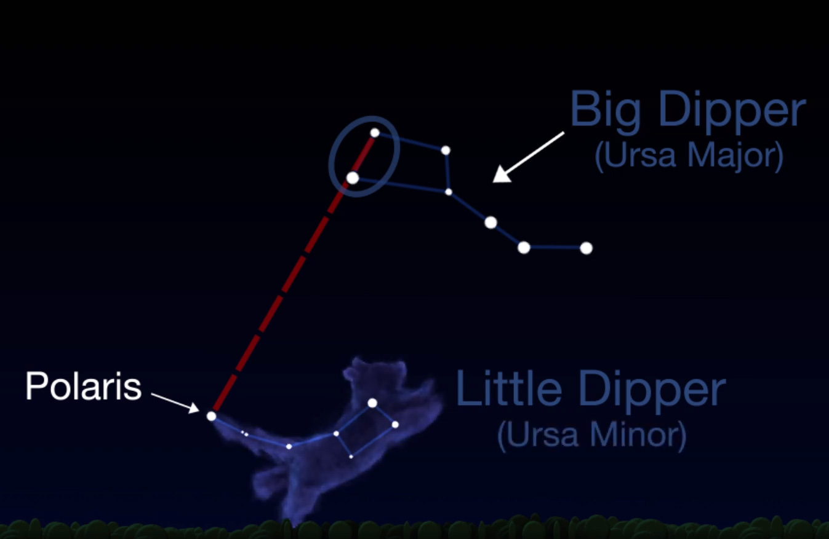
Podium Script (print on back picture)

North Star Cubmaster Minute
When you go out to look at the stars at night, in the northern sky is the North Star called Polaris. For centuries, we have known that the North Star is fixed in the heavens, and it has been used for navigation by sailors ever since the first adventurers sailed away from the sight of land.

The North Star is still used that way by mariners and space explorers. There are other guiding stars in our everyday lives, too. One of them is our conscience. If we listen to our conscience, we can be sure to steer our lives in the right direction.

In Scouting we have our own North Star, the Scout Oath and Law. They are our guiding stars, because they give us excellent guidance in how to behave and what we owe to God, country, our fellow human beings, and to ourselves.

When you're lost at night, look for the North Star. The rest of the time, steer your life with those other guiding stars, the Scout Oath and Law.

Closing Ceremony: Print for back of posters

Space Shuttle Closing Ceremony:a

The word CUBS is spelled out on a poster board replica of a space shuttle. "Fanfare of the Common Man" by Aaron Copeland or similar music is played in the background. A flashlight or other light lights each letter as it is shown. Parts may be read by Cubs (preferably) or adults.

Cub Scout #1: C stands for Catch. Catch the spirit of Scouting and you're starting the countdown.

Cub Scout #2: U stands for Unite. When we unite, we see how much we can do and how important teamwork really is.

Cub Scout #3: B stands for Balance. In Scouting, the hard work that we do can be fun. As a Scout, work and fun are balanced.

Cub Scout #4: S stands for Straight. The Scout Oath and Law remind us that if our arrow is true, we may cross the bridge and become Scouts in troops.

Cub Scout #5: Together these letters form the vehicle that will transport us to the outer limits of Scouting in hopes of one day being able to say those well-earned words, "Another Eagle Has Landed.

CHEERS

Cheers and applauses are a great way to recognize Scouts and Scouters at den or pack meetings for accomplishments and performances. Cheers add fun to den meetings, pack meetings and campfire programs.

Before starting a cheer or applause, make that everyone knows and understands how to do it. Cheers and applauses serve more than one purpose -- they not only provide recognition but also help liven up a meeting. They need to be fun. Strive for quality of performance. Another important side effect is they provide” wiggle time” for Scouts and siblings during the ceremonies so they sit still during the serious moments. It is a lot easier and a lot less stressful to lead a cheer and have fun than to be constantly reminding the Scouts to sit quietly.

How to Make a Cheer Box. The cheer graphic can be printed and attached to a blue bag or a box wrapped in blue construction paper. Print the cheers on strips of paper and keep generic cheers stuffed in the box. Use theme-based cheers for special meetings. Assign someone (e.g., assistant Cubmaster) to jump up and enthusiastically lead cheers throughout the meeting (e.g., after a skit or advancement ceremony). Let a Scout pull a cheer out of the box and help lead it. Download the cheer box graphic at shac.org/cheers

Print: Cheers and Applauses (cut into strips and put in Cheer box)
Apollo Shout: Countdown, 0, 9, 8, 7, 6, 5, 4, 3, 2, 1, blast off! Then with your hand gain orbit and even out. Then say, "BEEP, BEEP, BEEP, BEEP."

Blast-off: Start counting backwards from 10 to 1. Bend the knees a little more on each count until you are in a squatting position. Then, while saying, "BLAST OFF!", jump straight up in the air.

Jet Breaking Sound Barrier: "Fly your hand like a jet saying "Zoooommmmm" then bring your other hand up and clap once as loud as you can and say "Booommm!"

Jet Plane Cheer: Move your hand around yelling "Zoom, Zoom" then add one big clap for the sonic boom.

Launch (Blastoff) Cheer I: Count down 10, 9, 8, 7, 6, 5, 4, 3, 2, 1 and toss a handkerchief into the air and cheer as loudly as they can until it hits the ground.

Launch (Blastoff) Cheer II:
  - Count down 10, 9, 8, 7, 6, 5, 4, 3, 2, 1 (squatting down lower with each number)
  - Yell “Blast Off” (as loudly as possible)
  - Go ZOOOooommmm!!
  - Go POW (real loud)
  - Then OOOooohh and AAAaaahh

Lightning Cheer: Shake your finger like jagged lightning yelling "Shhhhh, Shhhh" on each movement. Throw in a "BOOM" every now and then.

Lights in The Sky Yell: Put fingers facing up and wiggle them while saying, "Twinkle, Twinkle."

Man In The Moon: Circle face with hands and say, "I love green cheese!!

Robot: Walk in place, stiff-legged, saying "Does not compute. Does not compute."

Rocket cheer: ZZZZZZZZOOOOOOOOOOMMMMMM!”

Rocket Ship Applause: Act as if lighting the fuse of a rocket (make hissing sound), raise arms as a rocket taking off (make "whooooosh" sound), make popping sound, then while moving hands in circle above head, go BOOM.

Satellite 1: Put your right hand over your head, making a circular motion with the right hand, opening and closing the right fist, while saying "Gleep, Gleep, Gleep".

Satellite 2: Begin with a countdown from 10, at zero, yell, "BLASTOFF! stretch arm over head saying "Gleep, Gleep, Gleep" and turn around three times.

Satellite Applause: Move 1ight hand in circle overhead, opening and closing the fist, while saying in a high falsetto voice "Gleep-gleep-gleep."

Saturn cheer: “Ring! Ring! Ring! That rings true!”

Sky Rocket 1: Make a motion of striking a match on your pants, lean over to light your rocket. Make a "SH, SH, SH" sound, point from the floor to the sky as if you were following it in flight with your finger. CLAP hands and say "BOOM" spread arms wide and say

Sky Rocket Cheer 2: Whistle up the scale and then shout "BOOM! AAAH!" As you whistle, gradually raise your hands and then gradually lower them on AAAH. Gradually soften the AAAH to complete silence. "AH
AH AH".

Supersonic: Wave arms wildly and open mouth as if yelling, then wait quietly for a few moments, then yell loudly.

UFO: Have the group look up, shade their eyes with one hand, point with the other and yell, "Look, it's a UFO!!!" Have them turn their heads as if the object is moving.

UFO Cheer: Hold index fingers to forehead and shout "TAKE ME TO YOUR LEADER."

Venus cheer: “Morning star, evening star, you’re a star to us!”

Blast Off Cheer:
We're blasting off into space! Where we spread goodwill
We'll leave no trace
We'll do our best
Right down to the wire
Helping our pack soar higher and higher! (Make rocket sounds.)

PACK MEETING HANDOUT

Edit the text boxes on the next two pages. An editable, word version of the document is available at www.shac.org/space-theme.
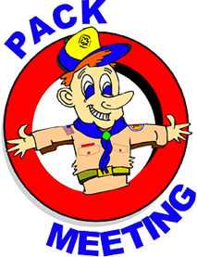
    - Page 1: insert pack number and month/year
    - Page 2: list detailed announcements, edit upcoming events for next three to six months, customize electronic communications.

Print one copy per person (of next two pages), one-sided to two-sided

Announcements: During meetings, keep announcement very short. Having detailed announcements printed in the handout saves times during meetings and avoids the dreaded long announcements that run on and on (that nobody can hear, nobody pays attention too and Scouts dislike). Encourage the parents to put the handout on their refrigerator. Parents will get used to getting a handout at each pack meeting.

In addition to upcoming pack events, Add district and council events. Visit www.shac.org/toolkit for upcoming council events. Visit your district website for upcoming district events.

Songs: have more songs than you think you need. You don’t have to sing them all, but having a back-up in case of a lull in the program is always helpful.

 | Pack <#> |  |  | <month year>
 |  | 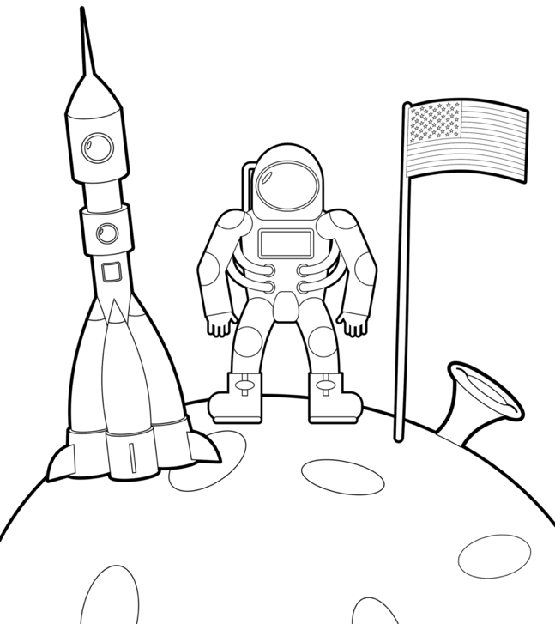
The Astronaut’s Plea  Tune: My Bonnie Lies Over the Ocean  I went for a ride in a spaceship,  The moon and the planets to see.  I went for a ride in a spaceship,  And listen to what happened to me.  Chorus: Bring back, bring back,  Oh bring back by spaceship to me, to me.  Bring back, bring back,  Oh bring back my spaceship to me.  I went for a ride on a spaceship.  The capsule was crowded and I  Developed a cramp in my muscles.  So, I took a walk in the sky.  Chorus  I went for a walk in my spacesuit.  The ship was controlled from the ground.  And someone in charge down at NASA  Forgot I was walking around.  Chorus |  |  |  |  | 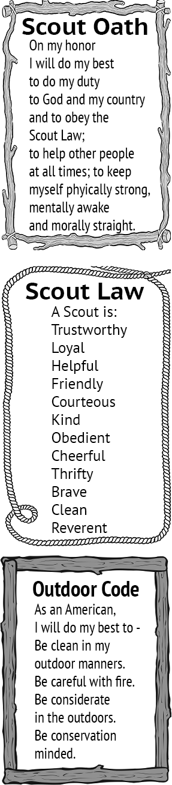
Life on other Planets
Tune: My Bonnie Lies Over the Ocean

Last night as I lay on my pillow,
And drifted off slowly to sleep.
I thought of the world of tomorrow
These thoughts through my mind did creep.

A computer will do all my homework,
A robot will do all the chores,
If I spend the whole day just playing,
I fear that I may become bored.

Chorus: Bring back, bring back
O bring back the old days to me, to me.
Bring back, bring back,
O bring back the old days to me.

My jet powered bike will be speedy,
I'll fly in my spaceship to Mars,
But what if I get lost in space,
And can't find my way through the stars?
Chorus
My parents will have their own rocket,
We'll travel through space very quick,
I'm not sure I'll like that fast travel,
I may even get space sick.
Chorus
Our family might move to Venus,
I don't know what we would find there,
I'd sure miss my friends back on Earth,
They're the best friends I'll find anywhere.
Chorus
Dehydrated food for breakfast,
Dehydrated food for lunch,
Oh, what I would give for a Big Mac
And potato chips that I can crunch.
Chorus

<list upcoming pack, district and council events  visit shac.org/toolkit for upcoming council event articles  visit district website for district events> |  |  |  | Upcoming Events  <Month Year>  <day> <event>  <day> <Den meeting>  <day> <Pack meeting>  <day> <District event>  <day> <Council event>  <Month Year>  <day> <event>  <day> <Den meeting>  <day> <Pack meeting>  <day> <District event>  <day> <Council event>  <Month Year>  <day> <event>  <day> <Den meeting>  <day> <Pack meeting>  <day> <District event>  <day> <Council event>  <Month Year>  <day> <event>  <day> <Den meeting>  <day> <Pack meeting>  <day> <District event>  <day> <Council event>  <Month Year>  <day> <event>  <day> <Den meeting>  <day> <Pack meeting>  <day> <District event>  <day> <Council event>
<insert pack committee / contact information > |  | Pack <#>  facebook.com/<insert URL>  <pack website>  <insert> District  <district website>  facebook.com/<insert URL>  Sam Houston Area Council  www.shac.org  facebook.com/shac.bsa

BANQUET PROGRAM

For banquets a more formal handout can be used.
Edit the text boxes in the next two pages (insert Scout’s names, upcoming events, pack number, agenda and date). An editable, word version of this document is available at www.shac.org/space-theme.

Print one copy per person (of next 2 pages), front to back.

Banquets: Most packs celebrate Scouting Anniversary Week in February with a birthday party called the blue and gold banquet; some packs do an end of the year banquet. It brings families together for fun and cheer. The purpose of a banquet is to celebrate the Scouting, thank leaders and volunteers, and inspire the leaders, Scouts, and parents.

The banquet can be like a regular pack meeting with songs, skits, stunts, and awards, or it can be something different and a little more special. The pack committee may decide to bring in an entertainer such as a mad scientist or magician and have a video or slide show of what the pack did over the past year.

A good banquet needs lots of careful planning at least two months in advance to be successful. The pack committee should recruit a banquet chair, who in turn may select others to carry out the responsibilities of the program, such as making physical arrangements, promotions, inviting special guests, decorations, choosing a theme, ordering food, etc.

A detailed plan for banquets, including a planning calendar, sample agenda, and suggested program activities, is available in the Cub Scout Leader How-To Book, No. 621165.

Banquet Planning: www.skcscouts.org/wp-content/uploads/2013/06/Blue-Gold-Planning-Guide.pdf

Banquet Planning: www.ocbsa.org/wp-content/uploads/2011/06/Blue-Golf-Banquet-for-Website.pdf

Lions
<List Lions>
Tigers
<List Tigers>
Wolves
<List Wolves>
Bears
<List Bears>
Blue and Gold
Banquet
Webelos Scouts
<List Webelos Scouts>

Pack 72

Upcoming Events
<date> <event>
<date> <event>
May 19, 2019
<date> <event>
<date> <event>
<date> <event>
<date> <event>

My parents will have their own rocket,
We'll travel through space very quick,
I'm not sure I'll like that fast travel,
I may even get space sick.

Chorus

Our family might move to Venus,
I don't know what we would find there,
I'd sure miss my friends back on Earth,
They're the best friends I'll find anywhere.

Dehydrated food for breakfast,
Dehydrated food for lunch,
Oh, what I would give for a Big Mac
And potato chips that I can crunch.

Chorus
Life on other Planets
Tune: My Bonnie Lies Over the Ocean

Last night as I lay on my pillow,
And drifted off slowly to sleep.
I thought of the world of tomorrow
These thoughts through my mind did creep.

A computer will do all my homework,
A robot will do all the chores,
If I spend the whole day just playing,
I fear that I may become bored.

Chorus: Bring back, bring back
O bring back the old days to me, to me.
Bring back, bring back,
O bring back the old days to me.

My jet powered bike will be speedy,
I'll fly in my spaceship to Mars,
But what if I get lost in space,
And can't find my way through the stars?

The Astronaut’s Plea
Tune: My Bonnie Lies Over the Ocean

I went for a ride in a spaceship,
The moon and the planets to see.
I went for a ride in a spaceship,
And listen to what happened to me.
Chorus: Bring back, bring back,
Oh, bring back by spaceship to me, to me.
Bring back, bring back,
Oh, bring back my spaceship to me.

I went for a ride on a spaceship.
The capsule was crowded and I,
Developed a cramp in my muscles.
So, I took a walk in the sky.
Chorus
I went for a walk in my spacesuit.
The ship was controlled from the ground.
And someone in charge down at NASA,
Forgot I was walking around.
Chorus

Gathering

Opening

Invocation

Dinner

Friends of Scouting Presentation

Advancement Ceremony

Song

Leader Recognition

Cubmaster Minute

Closing

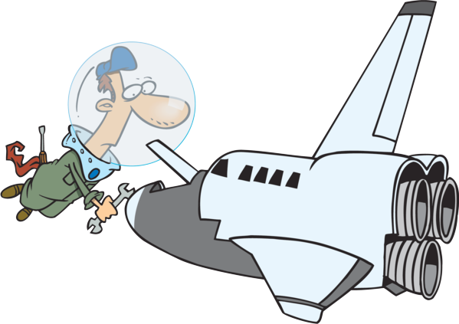

ABOUT PACK MEETINGS

Before the Meeting prepare all materials and notify each person responsible for a part of the program. Plan to arrange the room (e.g., chairs, tables, flags, sound system) and set up equipment, materials (e.g., advancements) and props with plenty of time to spare so the meeting can start on time.

Gathering (optional). As the Cub Scouts begin to arrive, they join in an informal activity (e.g., activity sheet) or game, often conducted by the den chief to keep everyone interested and active until the entire group has arrived. The gathering activity must be done prior to the formal start of the meeting as it encourages everyone to arrive on time so the meeting can start on time. Consider assigning greeters at the door to welcome Cub Scouts, guests, and families to the pack meeting. Find gathering activities here.

Welcome: The Cubmaster welcomes everyone to the pack meeting and makes any necessary introductions.

Opening: The opening ceremony is the official start to the meeting and sets the stage. It can reinforce the purpose of Scouting and help make the Scouting ideals meaningful through the words and pictures of the ceremony. One of the points of the Scout Law can be highlighted each month. Be award of physical and/or mental disability challenges. Be sensitive that not all youth may be able to read or talk in front of a group. Adapt ceremonies in a sensitive way to involve everyone at the level they will feel comfortably involved. Pre-select a den to lead the opening ceremony and have the den leader practice with the Scouts for several meetings prior. Have posters with a picture on one side and the script printed with large letters on the back. Teach the Scouts how to talk with their head up and project their voice to the people in the back of the room. Find opening ceremonies here and in the Cub Scout Ceremonies for Dens and Packs, No. 33212.

Flag Ceremony: Pre-select a den to lead the pledge and have the den leader practice flag etiquette with the Scouts for several meetings prior. The same den that conducted the opening can also conduct the opening ceremony. Consider group recitation of the Scout Law, Scout Oath and Outdoor Code after the pledge. The pocket guide can assist the Scouts: https://shac.org/Data/Sites/1/media/instep/flag-ceremony.pdf.

Invocation. Find invocations here.

Program The pack meetings, the program is reserved for dens who have requirements for adventures to share or demonstrate something they have learned. This can also be used as a time a song or skit.

For blue and gold banquets, the pack committee may decide to bring in an entertainer such as a scientist or magician and have a video or slide show of what the pack did over the past year. Each unit is requested to hold a Friends of Scouting (FOS) presentation typically at the blue and gold banquet. The presentation, which takes approximately seven minutes to conduct, informs parents and leaders of all council services, its financial needs and extends an opportunity to help fulfill the need. The FOS campaign is a vital component to the programs and services of the council. The money offsets cost of training leaders, operating camps, and the service center, as well as providing other resources to units in the council.

Songs. Singing builds pack spirit and enthusiasm. Singing gives Cub Scouts a chance to let off steam. Singing is fun! Use a song or two to set the mood for meetings, to get the audience moving and get rid of those wiggles or to quiet and calm the group when it’s time to go. Have a few songs ready to use as fillers during transition times. Pre-select a den to lead a song in the meeting handout. Songs can be found here and in the Cub Scout Leader How-To Book, No. 33832 and Cub Scout Songbook, No. 33222.

Leader Recognition (for banquets and other meetings as appropriate). When working with volunteers, thanks is the only payment we can really give them. Public recognition is the most valued form of payback for volunteers – so remember to recognize parents, leaders and others who help the program! Consider a hand written thank you note, homemade award, certificate of appreciation, or gift from the Scout Shop. Consider submitting pack leaders for adult awards and recognitions (e.g., training awards) or district awards that they qualify for and presenting them at the blue and gold banquet. Find leader recognition ceremonies here.

Skits (optional). Skits appeal to Cub Scouts. Acting comes naturally to many Cub Scouts, and help channel youth imagination. Skits give a chance for creative expression, gaining self-cofidence, and teamwork and coopration. Some shy kids many not want to take part in skits and might be give responsibilities for handling props or “directing.” Have a den leader select a skit and practice for several meetings prior. Skits can also be found in the Cub Scout Leader How-To Book, No. 33832. The Cub Scouts should be taught how to talk clearly, slowly, loudly and to the back row of the audience (or speaking into the microphone correctly).

Run-ons are similar to skits but are much shorter and require only one or two people. Run-ons are good for a change of pace during pack meetings and campfires – something to make everyone laugh and relax. They come in handy as fill-ins between acts to fill dead time or to enliven the program.

Audience Participation (optional) stories add variety, action and fun to pack meetings. Some include motions. Some require the adience be dived into groups that respond to a key word in a story read by a a leader. It’s a good idea to let groups practice their motions or phrases first. Find participation skits here and the Cub Scout Leader How-To Book, No. 33832.

Advancement Ceremony. Recognition is important to Cub Scouts. Each one represents a great amount of time and effort on the part of the Cub Scout, family, and leaders and should be presented in a special ceremony. The presentation should be worthy of the award and the work that went into it. When Cub Scouts are recognized for their accomplishments, they are motivated to achieve more. Memories of meaningful, impressive ceremonies will last years. Depending on the advancements that you have for each month’s pack meeting, you’ll need to adapt ceremonies. Delete sections that relates to a badge that you are not presenting or change that section to a narrative form in place of the badge presentation. Use your imagination to make the ceremonies work for you. A variety of leaders can be involved in the advancement ceremony (e.g., advancement chair, Cubmaster, assistant Cubmasters, den leaders, den chiefs). Use simple props and costumes to enhance ceremonies. Some ceremonies will be simple (monthly awards) while others are more involved (e.g., rank ceremonies, crossover ceremonies, Arrow of Light ceremonies). Find advancement ceremonies here and in the Cub Scout Den and Pack Ceremonies, No. 33212.

Games (optional). Are part of the fund of Scout Scouting and can help youth develop self-conficence, independence and the ability to get a long with others. Games teach youth to follow rules, take turns, responsibt the rights of others, to give and take and to play fair. Games can be effective during pack meetings as long as the meeting doesn’t run too long. Consider the physical aspect, age of the youth, space requirements, time requirements, equipment, skills and abilities, number of players needed, equipment and purpose (physical, mental, educational). Games can be found a here and in the Cub Scout Leader How-To Book, No. 33832 has a whole section on cooperative games.

Announcements. Announcements should be kept very short. Announcement details (e.g., date, time, address, description of event, who can attend, what to bring, web page to find more information) should be provided in pack meeting handout. The Cubmaster should take only about one minute to enthusiastically highlight the exciting upcoming activities and then let adults to read about in their pack meeting handout.

Cubmater Minute. At the end of a pack meeting filled with learning, fun, and fellowship comes the grand finale, the Cubmaster Minute. Consider it a closing argument to your Scouts — one last chance to inspire before they head home. Find a message that’s relevant, powerful, and memorable that can be crammed into 60 seconds. It’s an opportunity to quiet the Cub Scouts and put them in a reflective mood before departing. Find Cubmaster Minutes here.

Closing: the closing ceremony is draws the meeting to an end. It’s usually serious and quiet and provides an opportunity to present a brief character lesson, a simple thought. Keep it simple.

Cheers. Silly cheers and applauses are a great way to recognize Scouts and Scouters at den or pack meetings for accomplishments and performances. Cheers and applauses add fun to den meetings, pack meetings, and campfire programs.

After the Meeting. The leaders review the events of the meeting, finalize plans for the next pack meeting, and review their progress toward the upcoming pack meeting.

Resources:
- Pack Meeting Resources: www.shac.org/pack-meetings
- BSA Pack Meeting Resources: www.scouting.org/programs/cub-scouts/pack-meeting-resources
- Pack Meeting Tips: https://blog.scoutingmagazine.org/2018/12/10/8-essential-tips-for-controlling-chaos-at-cub-scout-pack-or-den-meetings/

